

SAVEETHA INSTITUTE OF MEDICAL AND TECHNICALSCIENCES
ASSIGNMENT 1

EVALUATE, DESIGN AND DEFEND A SECURE PATIENT-RECORD EXCHANGE STRATEGY FOR A MULTI-HOSPITAL HEALTHCARE NETWORK
Rubric-aligned complete answer
Student details | Information
Student Name | Mukesh M
Register Number | 192521368______________________________
Department / Section | Information Technology
Academic Year / Semester | __2025-2029______________________________
Faculty Name | __Dr Sivashankar C_____________________________
Date of Submission | _ 02 – 11 - 2026___________________________

Task | Rubric focus | Marks | Where addressed
1 | Threats, attacks and risk evaluation | 4 | Section 1: definitions, 7 ranked attacks, likelihood × impact
2 | Security goals mapping | 3 | Section 2: function-to-goal mapping and classical-cipher limitations
3 | Bell-LaPadula application and critique | 5 | Section 3: levels, compartments, 16 access decisions, emergency/declassification
4 | Cipher design | 4 | Section 4: five schemes, formulas, keys and 20+ character examples
5 | Mathematical analysis | 5 | Section 5: key spaces, modular formulas, Hill inverses
6 | Cryptanalytic resistance | 4 | Section 6: brute force, frequency, Kasiski/IC, known-plaintext attacks and ranking
7 | Transposition/product ciphers | 3 | Section 7: 20-row table experiment and layered-cipher analysis
8 | Steganography evaluation | 3 | Section 8: image LSB, text acrostic, capacity, PSNR, chi-square, JPEG
9 | Implementation and testing | 4 | Section 9: Python implementation, edge cases and reproducible commands
10 | Experimental evidence | 3 | Section 10: frequency, IC, timing, attack and image results with interpretation
11 | Final design recommendation | 4 | Section 11: defended design, risks and key distribution
12 | Day-4 design challenge | 8 | Section 12: impact, original-design evaluation, redesign and evidence defence
TOTAL |  | 50 | All rubric tasks included

Executive summary
A regional healthcare network must exchange clinical notes, prescriptions, laboratory results, diagnostic reports and billing records between one central hospital and 25 satellite clinics. The system must protect confidentiality, detect unauthorized changes, restrict staff access by clearance, and remain usable in low-resource clinics. The assignment requires a solution built from classical cryptographic techniques and Bell-LaPadula access-control reasoning, while judging their actual weaknesses.
The analysis identifies prescription modification and insider key/ciphertext collection as the most serious risks because they can cause patient harm or expose many records. Bell-LaPadula provides a useful confidentiality policy through “no read up” and “no write down”, extended with compartments, but it does not provide integrity, authentication or emergency flexibility by itself. Caesar, monoalphabetic substitution, Vigenère, Hill and columnar transposition are implemented and compared using worked examples and mathematical key-space analysis. The experiments show that repeated-key Vigenère leaks statistical structure, simple substitution preserves frequency patterns, Hill is vulnerable to known plaintext, and transposition preserves monogram frequencies.
For the academic design, a layered Vigenère-plus-columnar-transposition process with separate clinic/session keys and Bell-LaPadula labels is the strongest practical combination among the evaluated classical options. It is still not safe for production patient data. A real deployment requires modern authenticated encryption, robust digital signatures, secure key establishment, tamper detection, access logging and clinical validation. These are outside the assignment’s classical-only constraint.

Scenario and assumptions
Role | Clearance level in the brief | Typical permitted work
Medical Director | Top Secret | Network-wide clinical oversight, authorized emergency review and controlled declassification
Specialist Doctors | Secret | Specialist consultation and relevant clinical records
Nurses and Lab Staff | Confidential | Nursing observations, sample handling and laboratory results
Billing and Front-Desk Staff | Restricted | Invoices, billing codes and appointment administration
Patients | Public | Their own approved public-facing summaries and instructions

Assumptions used in worked examples: (1) A–Z is mapped as A=0 through Z=25 for mod-26 ciphers. (2) For the mod-36 Hill example, the alphabet is A–Z followed by 0–9; spaces and hyphens are formatting separators and are removed before encryption, then restored from saved formatting metadata after decryption. (3) The 20-row laboratory table and 256×256 scan are synthetic test data. (4) Risk scores use a 1–5 scale for likelihood and impact; risk score = likelihood × impact.

TASK 1 - Evaluate Threats, Attacks and Risks (4 Marks)

1.1 Distinguish the key risk terms
Term | Meaning | Healthcare example
Threat | A potential cause of harm. | A dishonest insider, external attacker or network failure.
Vulnerability | A weakness that makes a threat exploitable. | One long-term key shared across clinics; predictable message headers; no integrity check.
Attack | A deliberate action that exploits a vulnerability. | Changing a prescription dosage or replaying an old medication order.
Risk | The likelihood and impact of an attack succeeding. | A forged prescription may cause an incorrect dose and patient injury.

1.2 Risk scale
Likelihood and impact are each scored from 1 (very low) to 5 (very high). The numerical score is L × I. The score is a prioritization aid, not a precise probability. Patient-safety impact receives greater weight in the written justification than privacy inconvenience alone.

1.3 Ranked attack assessment
Rank | Attack | Class | L | I | Score | Reason for rating
1 (tie) | Modification of prescription / dosage | Active | 4 | 5 | 20 | A changed medicine or dose can directly injure a patient; public-network transfer and missing integrity protection make it plausible.
1 (tie) | Insider copies ciphertexts / obtains a shared key | Passive collection; can enable later active abuse | 4 | 5 | 20 | A clinic insider can collect many records; a reused key exposes a large historical corpus and may support forgery.
3 | Eavesdropping on clinical traffic | Passive | 4 | 4 | 16 | Diagnosis, allergy and treatment details are sensitive; public-network traffic is observable.
4 (tie) | Masquerade as a doctor | Active | 3 | 5 | 15 | A forged identity can create or approve unsafe orders; impact is high even if successful impersonation is less frequent.
4 (tie) | Replay of an old prescription/order | Active | 3 | 5 | 15 | An authentic old instruction may become dangerous when resent after a dose or treatment has changed.
6 (tie) | Denial of service on record system | Active | 3 | 4 | 12 | Blocks record access during care; availability affects safety.
6 (tie) | Traffic analysis | Passive | 4 | 3 | 12 | Timing and message size may reveal clinic activity without revealing content.

1.4 Priority decision
The first immediate control priority is prescription modification because it has a direct, potentially irreversible patient-safety consequence. The insider key/ciphertext collection is a co-equal strategic priority: once a shared key is exposed, confidentiality across multiple clinics may fail and an attacker may gain the ability to create convincing ciphertexts. The response should therefore contain both risks: verify prescription values through an independent clinical confirmation process, stop reuse of the exposed key, isolate affected clinic credentials, and review records sent under the compromised key.

TASK 2 - Map and Judge Security Goals (3 Marks)
The five goals required by the brief are confidentiality, integrity, availability, authentication and non-repudiation. Their importance differs by system function.
System function | Confidentiality | Integrity | Availability | Authentication | Non-repudiation
Record upload | High - diagnoses and identifiers are sensitive. | High - record fields must not be changed unnoticed. | High - clinicians need the record when treating the patient. | High - identify the uploader and clinic. | Medium - preserve who submitted the record.
Prescription transmission | High - treatment details are private. | Critical - drug, dose, route and frequency must remain exact. | Critical - delayed or unavailable orders can harm care. | Critical - prove the order came from an authorized prescriber. | High - support responsibility for an order and its approval.
Specialist consultation | High - consultation often contains sensitive diagnoses. | High - the opinion and response must not be altered. | High - specialists must respond in a useful time. | High - identify both requesting and responding clinicians. | High - preserve the origin of advice and decisions.

2.1 What classical ciphers can and cannot provide
Security goal | What a classical cipher contributes | What it does not provide
Confidentiality | A secret key can obscure the message from a casual observer. | Simple substitution, repeated-key Vigenère, Hill and transposition are vulnerable to known cryptanalysis; they do not offer modern security.
Integrity | No inherent protection. | A ciphertext can be changed; decryption may produce altered plaintext without an alarm.
Authentication | A secret key may suggest that the sender knows the key. | Any holder of a shared key can impersonate another holder; no strong sender identity proof.
Availability | No direct contribution. | A cipher cannot prevent outages, congestion or denial-of-service attacks.
Non-repudiation | No strong contribution. | Shared-key encryption cannot prove which key-holder created a message; there is no asymmetric signature in the permitted classical design.

2.2 Why correct decryption is not proof of authenticity or integrity
Successful decryption proves only that the ciphertext can be transformed using the selected key and algorithm. It does not prove that the sender was the correct doctor. If several people know the same key, any of them can create a ciphertext that decrypts correctly. It also does not prove that a dosage was not modified: many classical ciphers have no authentication tag or cryptographic checksum, so altered ciphertext may decrypt to altered text. A separate integrity and identity mechanism is required in a real system.

TASK 3 - Apply and Critique the Bell-LaPadula Model (5 Marks)

3.1 Security levels and compartments
Bell-LaPadula (BLP) is a confidentiality model. The network’s levels are ordered: Public < Restricted < Confidential < Secret < Top Secret. Each subject and object also receives a compartment label. A subject dominates an object only when its clearance is at least as high and its authorized compartment set contains every compartment on the object.
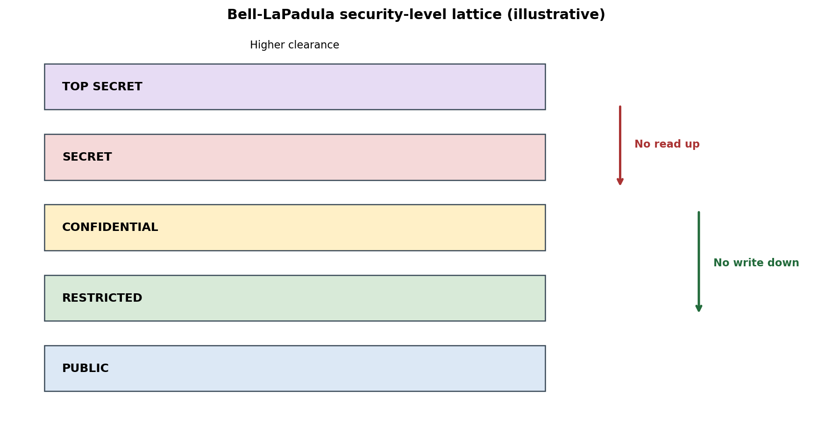
Figure 1. Security levels. Compartment matching is an additional requirement, not shown by level height alone.
Subject | Level | Compartments (illustrative)
Medical Director | Top Secret | CLINICAL, LAB, ONCOLOGY, PSYCHIATRY, ALLERGY, MEDICATION, BILLING, ADMIN
Specialist Doctor | Secret | CLINICAL, LAB, ONCOLOGY, ALLERGY, MEDICATION
Nurse / Lab Staff | Confidential | CLINICAL, LAB
Billing / Front Desk | Restricted | BILLING
Patient | Public | OWN-RECORD

Object | Label | Purpose
Psychiatry consultation note | Top Secret / CLINICAL + PSYCHIATRY | Restricted highly sensitive clinical note.
Oncology diagnosis | Secret / CLINICAL + ONCOLOGY | Specialist-level diagnosis.
Allergy record | Secret / CLINICAL + ALLERGY | Sensitive allergy information.
Medication order | Secret / CLINICAL + MEDICATION | Prescriber-controlled instruction.
Lab result | Confidential / CLINICAL + LAB | Laboratory result for clinical use.
Nursing observation | Confidential / CLINICAL | Routine nursing record.
Invoice | Restricted / BILLING | Administrative billing record.
Approved discharge summary | Public / OWN-RECORD | Sanitized patient-facing copy, not the full clinical record.

3.2 BLP properties
- Simple security property (“no read up”): a subject may read an object only when the subject dominates the object. A lower-level subject cannot read a higher-level object.
- *-property (“no write down”): a subject may write only to an object that dominates the subject. This prevents a high-level subject from writing sensitive information into a lower-level object.
- Compartment rule: the subject must possess the object’s required categories for a read. For a write-up, the destination must be at least as high and its compartments must safely contain the subject’s active categories.

3.3 Worked access decisions (16 requests)
“Allow” means the level and compartment checks pass. “Deny” means at least one BLP condition fails. The emergency override is deliberately shown separately from normal BLP decisions.
No. | Subject | Requested action / object | Decision | Reason
1 | Medical Director | Read Top Secret psychiatry note | ALLOW | Top Secret clearance and all required compartments.
2 | Specialist | Read Secret oncology diagnosis | ALLOW | Secret clearance and CLINICAL + ONCOLOGY compartments.
3 | Specialist | Read Top Secret psychiatry note | DENY | No read up: Secret is below Top Secret; PSI compartment also absent.
4 | Specialist | Read Secret allergy record | ALLOW | Secret clearance and ALLERGY compartment are present.
5 | Nurse | Read Confidential lab result | ALLOW | Confidential clearance and CLINICAL + LAB compartments match.
6 | Nurse | Read Secret allergy record | DENY | No read up: Confidential is below Secret; ALLERGY compartment is absent.
7 | Billing staff | Read Restricted invoice | ALLOW | Restricted clearance and BILLING compartment match.
8 | Billing staff | Read Confidential lab result | DENY | No read up and no CLINICAL/LAB compartments.
9 | Patient | Read approved Public discharge summary | ALLOW | Public object carries the patient’s OWN-RECORD category.
10 | Patient | Read Confidential raw lab result | DENY | No read up: Public is below Confidential; compartment mismatch.
11 | Nurse | Write Confidential nursing observation | ALLOW | Same level; no write-down violation; CLINICAL compartment matches.
12 | Nurse | Write up to Secret clinical-lab review queue (CLINICAL + LAB) | ALLOW | Secret dominates Confidential and the destination includes the nurse’s active CLINICAL + LAB compartments; specialist review is still required.
13 | Specialist | Write Secret consultation note | ALLOW | Same level and authorized clinical compartments.
14 | Specialist | Write Secret clinical details into Restricted invoice | DENY | No write down: Secret subject cannot write to Restricted object.
15 | Medical Director (trusted process) | Create sanitized Public discharge summary from Confidential source | CONDITIONAL ALLOW | Only a separate, minimized copy may be downgraded after authorized declassification and audit; do not relabel the original.
16 | Nurse in emergency | Read Secret allergy data through break-glass | DENY under base BLP | Normal BLP still denies the read. A separate emergency override may temporarily elevate and authorize access with reason, scope, expiry and review.

3.4 Emergency access, declassification, tranquility and trusted subjects
Emergency: a nurse may urgently need a Secret allergy record to avoid a dangerous drug interaction. Strict BLP denies the request because the nurse is Confidential. A healthcare system therefore needs a carefully controlled break-glass process outside the base model: record the emergency reason, obtain an authorized temporary elevation or trusted intermediary, restrict the record and time window, alert the responsible clinician, and review the access afterwards. This is an explicit, auditable exception, not proof that normal BLP permits read-up.
Declassification: a Medical Director or trusted release process may create a separate Public discharge summary after removing sensitive fields. The original Secret/Confidential object retains its label. The declassification decision must identify the trusted subject, fields released, purpose and timestamp. Uncontrolled downgrading creates a direct leakage path.
Tranquility: strong tranquility keeps security labels fixed while the system runs. Weak tranquility permits label changes only when they do not violate the policy. Medical records often need legitimate reclassification and release, so changes should be performed by trusted subjects under documented rules. Trusted subjects can be dangerous because they have authority to change labels or bypass ordinary checks.

3.5 Critical evaluation and verdict
- BLP controls confidentiality but does not guarantee data integrity. It cannot detect a changed dosage or forged laboratory value.
- It does not prove user identity, provide non-repudiation or stop an authorized insider from copying information they are allowed to read.
- Covert channels may leak information through timing, resource use or other observable behaviour not captured by simple read/write rules.
- Rigid labels can delay emergency treatment. Break-glass and declassification need a governed extension.
Verdict: BLP is useful as one confidentiality control, especially with compartments and audited exceptions, but BLP alone is not suitable for a complete healthcare security system.

TASK 4 - Design the Cryptographic Strategies (4 Marks)
The common 21-character message used to compare the schemes is PATIENTRECORDTRANSFER. It is a clinical-transfer phrase from the scenario. For alphabetic examples, spaces and punctuation are removed before encryption.

4.1 Caesar cipher (monoalphabetic shift)
Key: integer shift k=3. Each letter is shifted three positions forward in A–Z. Formula: C = (P + k) mod 26. Decryption: P = (C - k) mod 26. The same shift is applied to every character.
Plaintext : PATIENTRECORDTRANSFER
Key : k = 3
Ciphertext: SDWLHQWUHFRUGWUDQVIHU
Decrypt : shift every ciphertext letter back by 3.
Why include it: Caesar is the simplest baseline. Its key space is tiny and every letter keeps a fixed substitution, making the scheme easy to brute-force and frequency-analyse.

4.2 Monoalphabetic substitution
Key: a permutation of the 26 letters. The example uses the following ciphertext alphabet aligned position-by-position with the normal alphabet.
Plain alphabet | Cipher alphabet
ABCDEFGHIJKLMNOPQRSTUVWXYZ | QWERTYUIOPASDFGHJKLZXCVBNM

Encryption substitutes each plaintext letter with the aligned ciphertext letter; decryption uses the inverse mapping. This is a one-to-one substitution and does not change the total frequency count of each letter, only its label.
Plaintext : PATIENTRECORDTRANSFER
Ciphertext: HQZOTFZKTEGKRZKQFLYTK
Key : QWERTYUIOPASDFGHJKLZXCVBNM
Why include it: it demonstrates that a very large key space does not automatically create security. Frequency and digram analysis can recover the substitution from sufficiently long language samples.

4.3 Vigenere cipher (polyalphabetic substitution)
Key: CLINIC, repeated to match the plaintext length. With A=0,...,Z=25: Cᵢ=(Pᵢ+Kᵢ) mod 26; Pᵢ=(Cᵢ-Kᵢ) mod 26. Nonletters, if present, are copied and do not consume a key character.
Plaintext : PATIENTRECORDTRANSFER
Repeated key: CLINICCLINICCLINICCLI
Ciphertext: RLBVMPVCMPWTFEZNVUHPZ
Why include it: different positions may encrypt the same plaintext letter differently, reducing the simple frequency signal. However, a repeated key creates periodic structure that Kasiski examination and index-of-coincidence analysis can exploit.

4.4 Columnar transposition
Key: HOSPITAL (8 columns). Write the plaintext row-wise, pad the final row with X, then read columns in alphabetical key order. The order of original columns is 7, 1, 5, 8, 2, 4, 3, 6 (1-based). Decryption fills those columns in the same order and reads rows across.
Row 1 | Row 2 | Row 3 (padding)
P A T I E N T R | E C O R D T R A | N S F E R X X X

Key order (alphabetical): A, H, I, L, O, P, S, T
Columnar ciphertext : TRXPENEDRRAXACSIRETOFNTX
Remove the three X padding symbols after decryption.
Why include it: it rearranges symbol positions instead of substituting symbols. It hides the original order and many adjacent digrams, but it preserves the exact monogram-frequency histogram.

4.5 Hill cipher (2×2 over mod 26)
Key matrix K = [[3,3],[2,5]]. Use column vectors of two letters and A=0,...,Z=25. Encryption: C=KP mod 26; decryption: P=K⁻¹C mod 26. The inverse is derived in Task 5.
Plaintext : PATIENTRECORDTRANSFER
Odd length: append X for the final pair
Padded text: PATIENTRECORDTRANSFERX
Ciphertext: TEDAZVETSSPJOXZIPMBEQT
Why include it: Hill uses matrix multiplication and mixes letters within each block. It is a meaningful mathematical comparison, but it is linear and can be recovered from enough independent known plaintext blocks.

TASK 5 - Mathematical Analysis of the Schemes (5 Marks)

5.1 Key-space derivations
Scheme | Key-space derivation | Example size | Approx. key bits
Caesar | 25 non-zero shifts | 25 | 4.64
Monoalphabetic | Any permutation of 26 letters: 26! | 403,291,461,126,056,355,584,000,000 | 88.38
Vigenere | A key of fixed length m has 26^m possibilities; for m=6: 26^6 | 308,915,776 for m=6 | 28.20 for m=6
Columnar transposition | For 8 distinct key columns: 8! | 40,320 | 15.30
Hill 2×2 mod 26 | Invertible matrices: |GL(2,Z26)| = |GL(2,F2)|×|GL(2,F13)| | 6 × 26,208 = 157,248 | 17.26
Hill 3×3 mod 36 | |GL(3,Z36)| = 2^9|GL(3,F2)| × 3^9|GL(3,F3)| | 19,016,370,487,296 | 44.11

For an n×n Hill key over mod 26, invertibility requires gcd(det(K),26)=1. Since 26=2×13, the determinant must be divisible by neither 2 nor 13. The key-space count follows from the Chinese remainder decomposition Z26 ≅ F2 × F13. For n=2: |GL(2,F2)|=(4−1)(4−2)=6; |GL(2,F13)|=(169−1)(169−13)=168×156=26,208; product=157,248.

5.2 Hill 2×2 inverse by hand
K = [[3,3],[2,5]]. Its determinant is det(K)=3×5−3×2=9. Since gcd(9,26)=1, the inverse exists. The multiplicative inverse of 9 modulo 26 is 3 because 9×3=27≡1 (mod 26).
For K = [ [3, 3], [2, 5] ]
adjugate(K) = [ [5, -3], [-2, 3] ]
K^-1 = 3 × adjugate(K) mod 26
= [ [15, -9], [-6, 9] ] mod 26
= [ [15, 17], [20, 9] ]
Check: K × K^-1 mod 26 = [ [1, 0], [0, 1] ].

5.3 Hill 3×3 key over mod 36
For the extended alphabet A–Z0–9, use K = [[1,1,0],[0,1,1],[0,0,1]]. Its determinant is 1, so gcd(1,36)=1 and the key is invertible. Its inverse is:
K^-1 mod 36 = [ [1, 35, 1],
[0, 1,35],
[0, 0, 1] ]
The matrix product K × K^-1 is the 3×3 identity matrix modulo 36.
Example mapping: A=0,...,Z=25, 0=26,...,9=35. Remove formatting separators before encryption. PT-20481 becomes PT20481 and pads with XX; AMOX 500MG becomes AMOX500MG. With the matrix above:
PT20481 -> 8L2U28OKX -> decrypt -> PT20481 (remove padding XX)
AMOX500MG -> M0OSV0CSG -> decrypt -> AMOX500MG

5.4 Does a large key space guarantee strength?
No. Monoalphabetic substitution has 26! possible keys (about 88.38 bits), yet every plaintext letter always maps to the same ciphertext letter. A sufficiently long English message preserves the relative frequency pattern under a relabeling, so statistical analysis can recover the mapping. Effective security depends on resistance to known attacks, key reuse, message structure and implementation—not only the raw number of keys.

TASK 6 - Evaluate Cryptanalytic Resistance (4 Marks)

6.1 Attacks and why they work
Scheme | Attack | Demonstration / reasoning | Why it succeeds or fails
Caesar | Brute force + frequency | Try all 25 non-zero shifts; score each candidate against English letter frequencies. | Only 25 candidate keys; one correct candidate normally produces readable text.
Monoalphabetic | Frequency + digram analysis | Count ciphertext symbols and compare rank pattern with E, T, A, O, I, N; use common digrams such as TH, HE, IN. | A fixed one-to-one mapping preserves frequency order and repeated patterns; the large 26! space does not prevent statistical recovery.
Vigenere | Kasiski + index of coincidence | Find repeated 3-letter groups; measure distances; common factors suggest key period. Then split text into columns by period and solve Caesar-like shifts. | A repeated keyword causes periodic alignment. Long ciphertext gives more repeated groups and more reliable statistics.
Hill 2×2 / 3×3 | Known-plaintext attack | For 3×3, arrange three independent plaintext blocks as columns of P and their ciphertext blocks as C. If P is invertible, K=CP⁻¹ mod 36. | Hill encryption is linear. A sufficient number of independent known block pairs reveals the matrix.
Columnar | Digram / anagram / structural analysis | Use preserved letter counts, likely word patterns and candidate column widths/key permutations. | Transposition moves positions but keeps every letter count exactly; repeated language structure leaks.

6.2 Worked Hill known-plaintext recovery
Use the mod-36 key from Task 5. Give the attacker the three plaintext blocks BAA, ABA, AAB. In numeric form these are the three standard basis vectors, so the plaintext matrix P=I. Encryption produces BAA, BBA, ABB; therefore C=K. The recovery equation is:
C = K P (mod 36)
P = I, hence P^-1 = I
K = C P^-1 = C
Recovered K = [ [1,1,0], [0,1,1], [0,0,1] ].
This is a deliberately clear known-plaintext demonstration. It shows why linear block encryption is not secure against enough independent plaintext/ciphertext pairs; it is not a claim that all random 3-block samples will form an invertible P.

6.3 Resistance ranking
Relative rank (weakest to stronger against casual analysis) | Judgement
1. Caesar | Tiny 25-key search; easily brute-forced.
2. Monoalphabetic substitution | Huge theoretical key space, but fixed letter mapping leaks frequency and digrams.
3. Columnar transposition | Preserves exact monogram frequencies; key search is finite and message structure remains.
4. Repeated-key Vigenere | Suppresses simple monogram matching, but periodic key reuse is exposed by Kasiski/IC on long ciphertext.
5. Hill (against simple frequency analysis only) | Block mixing makes simple single-letter substitution less direct, but known-plaintext linear algebra defeats it.
Layered substitution + transposition | Best among these demonstrations against casual single-technique attacks; still vulnerable and not modern secure.

This is a threat-model ranking, not a universal security theorem. Under a known-plaintext attack, Hill can fall quickly; under a long repeated-key corpus, Vigenere can also fall. No scheme in the list is acceptable as a modern patient-record cipher.

TASK 7 - Assess Transposition and Product Ciphers (3 Marks)

7.1 Twenty-row laboratory-table experiment
The following 20 readings are synthetic integer placeholders, not real clinical measurements. The table is serialized as rows and columns, encrypted with the columnar key HOSPITAL, and decrypted to verify that the original table is recovered exactly.
Synthetic row ID | Synthetic reading value
S001 | 120
S002 | 98
S003 | 140
S004 | 4
S005 | 13
S006 | 92
S007 | 5
S008 | 110
S009 | 75
S010 | 8
S011 | 101
S012 | 4
S013 | 14
S014 | 130
S015 | 96
S016 | 7
S017 | 125
S018 | 89
S019 | 3
S020 | 118

Serialized table length: 160 characters. Columnar ciphertext length: 160 characters. First 80 ciphertext characters (line-feed shown as <LF>): 291,1951780443972831S<LF><LF>0<LF><LF><LF>S<LF><LF>S<LF>SS<LF><LF>S<LF><LF>S,230567,90,2,,56,89,084432<LF>05<LF>1<LF><LF>06<LF>59<LF>8. Exact decryption test: True.

7.2 Classical checksum and tamper tests
Use two unkeyed checksums on the ordered reading values v₁,...,v₂₀: simple checksum S=Σvᵢ mod 256; weighted checksum W=Σ(i×vᵢ) mod 256. The weighted checksum is more sensitive to row position, but neither is cryptographically secure.
Test case | Simple S | Weighted W | Interpretation
Original table | 72 | 72 | Baseline.
Change row 8 value by +1 | 73 | 80 | Both checksums change; the modification is detected if the stored checksums are trusted.
Swap rows 2 and 9 | 72 | 233 | Simple sum is unchanged; weighted checksum detects this example.
Add 5 to row 1 and subtract 5 from row 2 | 72 | 67 | Attacker preserves the simple sum; the weighted result changes in this example.

An attacker who understands the unkeyed checksum can calculate a replacement checksum after modifying the table. A compensating pair of edits can also preserve a simple sum. Therefore, a classical checksum detects accidental errors and some unsophisticated tampering, but it does not authenticate the sender or resist an informed active attacker.

7.3 Substitution followed by transposition
Design | Frequency behaviour | Assessment
Substitution only | Plaintext frequencies are relabelled; the frequency shape remains. | Vulnerable to monoalphabetic frequency and digram analysis.
Transposition only | Exact letter counts are unchanged. | Hides order, but monogram histogram is identical.
Substitution then transposition | Letter counts remain the substitution-permuted counts; adjacency and digrams are further rearranged. | Stronger than either simple layer for casual inspection, but statistical analysis and known plaintext still apply.

Practicality: manually applying multiple keys to clinical records at rural clinics is error-prone and slow. If used for a classroom demonstration, the process should be automated behind a simple interface, with controlled key entry and error messages. Manual cipher work should not delay treatment or be used on production records.

TASK 8 - Evaluate Steganography (3 Marks)

8.1 LSB image embedding design
For a grayscale image, each pixel is one byte. Embed each payload bit into the least-significant bit (LSB) of successive pixels. Store a 32-bit payload-length header first. Extraction reads the header, then reads exactly that number of payload bits. The report should be encrypted before embedding; hiding alone does not conceal the report’s meaning if the embedding is discovered.
Embedding: payload = encrypt(report)
bits = 32-bit length || payload bits
pixel[i] = (pixel[i] AND 254) OR next_bit
Extraction: read 32 LSBs -> payload length
read length × 8 LSBs -> payload
decrypt(payload)

8.2 Text circular method: acrostic
A simple text-only method is to hide one letter in the first character of each sentence or line. For example, the initial letters S-A-F-E across four lines encode “SAFE”. The receiver extracts the first letter of each line in order. This method has very low capacity and is easy to notice if the carrier’s sentence starts look unnatural.
Secure records are transferred through the clinic network.
Authorized staff review each record before release.
Files are checked for format and patient identity.
Every emergency access is logged for later review.
Extracted initials: SAFE

8.3 Comparison with encryption
Criterion | Encryption | Steganography
Purpose | Makes content unreadable without the key. | Conceals the existence of a message inside a carrier.
Capacity | Can protect a full record, limited mainly by cipher input length. | Limited by carrier size and acceptable distortion; text acrostics have very low capacity.
Imperceptibility | Ciphertext is visibly transformed and may attract attention. | A good embedding may be visually subtle.
Robustness | Ciphertext can survive copying if preserved exactly. | LSB data is fragile under resizing, filtering, format conversion and lossy compression.
Detectability | Ciphertext is obvious as encrypted data. | Statistical tests may detect unusual pixel distributions or embedding patterns.
Confidentiality | Protects meaning only if the cipher/key remain secure. | Does not encrypt the hidden payload; discovery reveals it unless separately encrypted.

8.4 Measured synthetic-image result
A reproducible 256×256 synthetic grayscale phantom was generated for the test. It is not a real medical scan and must not be interpreted as clinical evidence. One LSB per pixel provides 65,536 bits (8,192 bytes) of raw capacity; after a 32-bit length header, 8,188 bytes remain. A 112-byte test report used 928 bits including the header, or 1.416% of raw capacity.

 | 
Figure 2. Synthetic grayscale test image before (left) and after LSB embedding (right); differences are visually subtle at normal viewing size.

Measure | Observed result | Interpretation
Image size | 256 × 256 pixels | Minimum size in the assignment is met.
Gross LSB capacity | 65,536 bits = 8,192 bytes | One bit per pixel, before the header.
Available after 32-bit header | 8,188 bytes | The header consumes 4 bytes.
Payload | 112 bytes; 928 embedded bits including header | 1.416% of raw bit capacity used.
PSNR | 69.6117 dB | Low mean-squared pixel change for this synthetic payload.
Pair-of-values chi-square | Cover 3538.1727; stego 3400.9906 | Exploratory statistic only; not a calibrated probability or universal detector.
Lossless PNG extraction | Exact payload recovered | LSB data survives this lossless save.
JPEG quality 95 extraction | Exact payload not recovered | Lossy compression changed LSB values; do not use JPEG for raw LSB payloads.
Medical safety trade-off: even if PSNR is high, LSB embedding changes pixel values. A small alteration may matter in a diagnostic image, especially around subtle structures or quantitative measurements. The original scan should remain immutable. Do not embed into diagnostic pixel data without a validated reversible method, a separate unmodified original, and radiologist/clinical approval. Prefer a separate encrypted sidecar or approved metadata channel.
Conclusion: steganography is appropriate only when concealing the existence of a small payload is a genuine requirement and carrier modifications are approved. It is not a replacement for encryption. Encrypt-then-embed improves confidentiality if the carrier is discovered, but LSB remains fragile under JPEG compression and other image processing.

TASK 9 - Implement and Test (4 Marks)
The accompanying Python file implements Caesar, mono alphabetic substitution, Vigenere, columnar transposition, Hill-26, Hill-36, frequency analysis, index of coincidence, Kasiski repeated-ngram distances, Caesar frequency cracking, synthetic image intensity shift, pixel permutation, LSB embedding/extraction, text-acrostic hiding, and laboratory checksums.

9.1 Correctness tests

Test | Input / edge case | Expected verification | Result
Caesar | PATIENTRECORDTRANSFER; key 3 | Decrypt(encrypt(m)) equals original. | PASS
Monoalphabetic | 21-letter phrase with fixed permutation | Inverse substitution restores original. | PASS
Vigenere | 21-letter phrase; key CLINIC | Repeated-key encrypt/decrypt round trip. | PASS
Columnar | 21-letter phrase; HOSPITAL key; X padding | Decrypt and remove known padding. | PASS
Hill-26 | Odd number of letters; punctuation and spaces | Pad one X; use original letter count to remove padding; preserve formatting. | PASS
Hill-36 | PT20481 and AMOX500MG | A–Z0–9 mapping; pad to 3-character blocks; decrypt and trim padding. | PASS
Punctuation/digits | Patient-ID: PT-20481, dosage 500MG! | Classical A–Z functions preserve nonletters; formatting separators are not encrypted by Hill-36. | PASS
Image transforms | All 256 byte values and synthetic 256×256 image | Intensity inverse and permutation inverse recover exact bytes. | PASS
Steganography | 112-byte test payload in lossless PNG | Extracted payload equals original payload. | PASS
JPEG robustness | Same LSB carrier saved at JPEG quality 95 | Exact recovery fails. | EXPECTED LIMITATION
Checksum | 20-row synthetic data; changed cell and swapped rows | Additive checksum misses the row swap; weighted checksum detects this example. | PASS

9.2 implemented code
import string
ALPH = string.ascii_uppercase

def clean(text):
return ''.join(ch for ch in text.upper() if ch in ALPH)

def caesar_encrypt(text, k):
return ''.join(ALPH[(ALPH.index(ch) + k) % 26] for ch in clean(text))

def caesar_decrypt(text, k):
return caesar_encrypt(text, -k)

def vigenere_encrypt(text, key):
text, key = clean(text), clean(key)
if not key:
raise ValueError("Key must contain letters")
return ''.join(ALPH[(ALPH.index(ch) +
ALPH.index(key[i % len(key)])) % 26]
for i, ch in enumerate(text))

def vigenere_decrypt(text, key):
text, key = clean(text), clean(key)
if not key:
raise ValueError("Key must contain letters")
return ''.join(ALPH[(ALPH.index(ch) -
ALPH.index(key[i % len(key)])) % 26]
for i, ch in enumerate(text))

def columnar_encrypt(text, order):
# order is a 0-based list giving columns in read-out order
text = clean(text)
n = len(order)
rows = [text[i:i+n] for i in range(0, len(text), n)]
cols = [''.join(row[c] for row in rows if c < len(row))
for c in range(n)]
return ''.join(cols[c] for c in order)

def columnar_decrypt(cipher, order):
n, L = len(order), len(cipher)
full, extra = divmod(L, n)
lengths = [full + (1 if c < extra else 0) for c in range(n)]
chunks, pos = {}, 0
for c in order:
chunks[c] = cipher[pos:pos + lengths[c]]
pos += lengths[c]
out = []
for r in range(full + (1 if extra else 0)):
for c in range(n):
if r < len(chunks[c]):
out.append(chunks[c][r])
return ''.join(out)

if __name__ == "__main__":
message = "PATIENT RECORD TRANSFER"
for enc, dec, key in [
(caesar_encrypt, caesar_decrypt, 3),
(vigenere_encrypt, vigenere_decrypt, "LEMON")
]:
cipher = enc(message, key)
plain = dec(cipher, key)
print(cipher, plain, plain == clean(message))
order = [2, 0, 3, 1]
cipher = columnar_encrypt(message, order)
plain = columnar_decrypt(cipher, order)
print(cipher, plain, plain == clean(message))

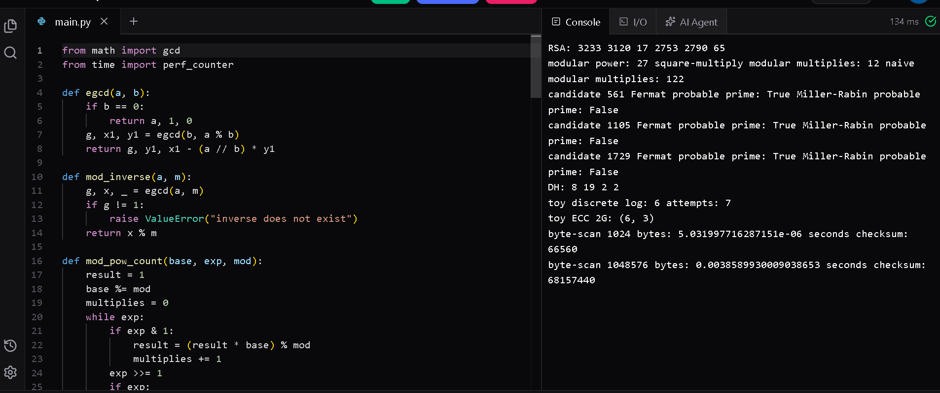

The self-test command completed successfully in the preparation environment. Benchmark results are generated by five-run medians. The source code uses the Python standard library for ciphers and measurements; Pillow and Matplotlib are used for image and chart experiments. Install optional libraries with: pip install pillow matplotlib.

9.3 Testing method and limitations
- The same normalized clinical-text corpus is sliced to 100, 1,000, 10,000 and 100,000 characters for each timed scheme.
- Each timing point is the median of five encryption runs and five decryption runs; every decrypt(encrypt(m)) check must return the original test string.
- Classical A–Z transformations preserve punctuation and digits as formatting characters. Hill-36 requires separators such as hyphens/spaces to be removed before encryption and restored using retained formatting metadata.
- The image experiment uses a synthetic phantom because no real de-identified scan was supplied. The experiment must not be described as clinical-image validation.

TASK 10 - Record and Interpret Experimental Evidence (3 Marks)

10.1 Letter-frequency histograms
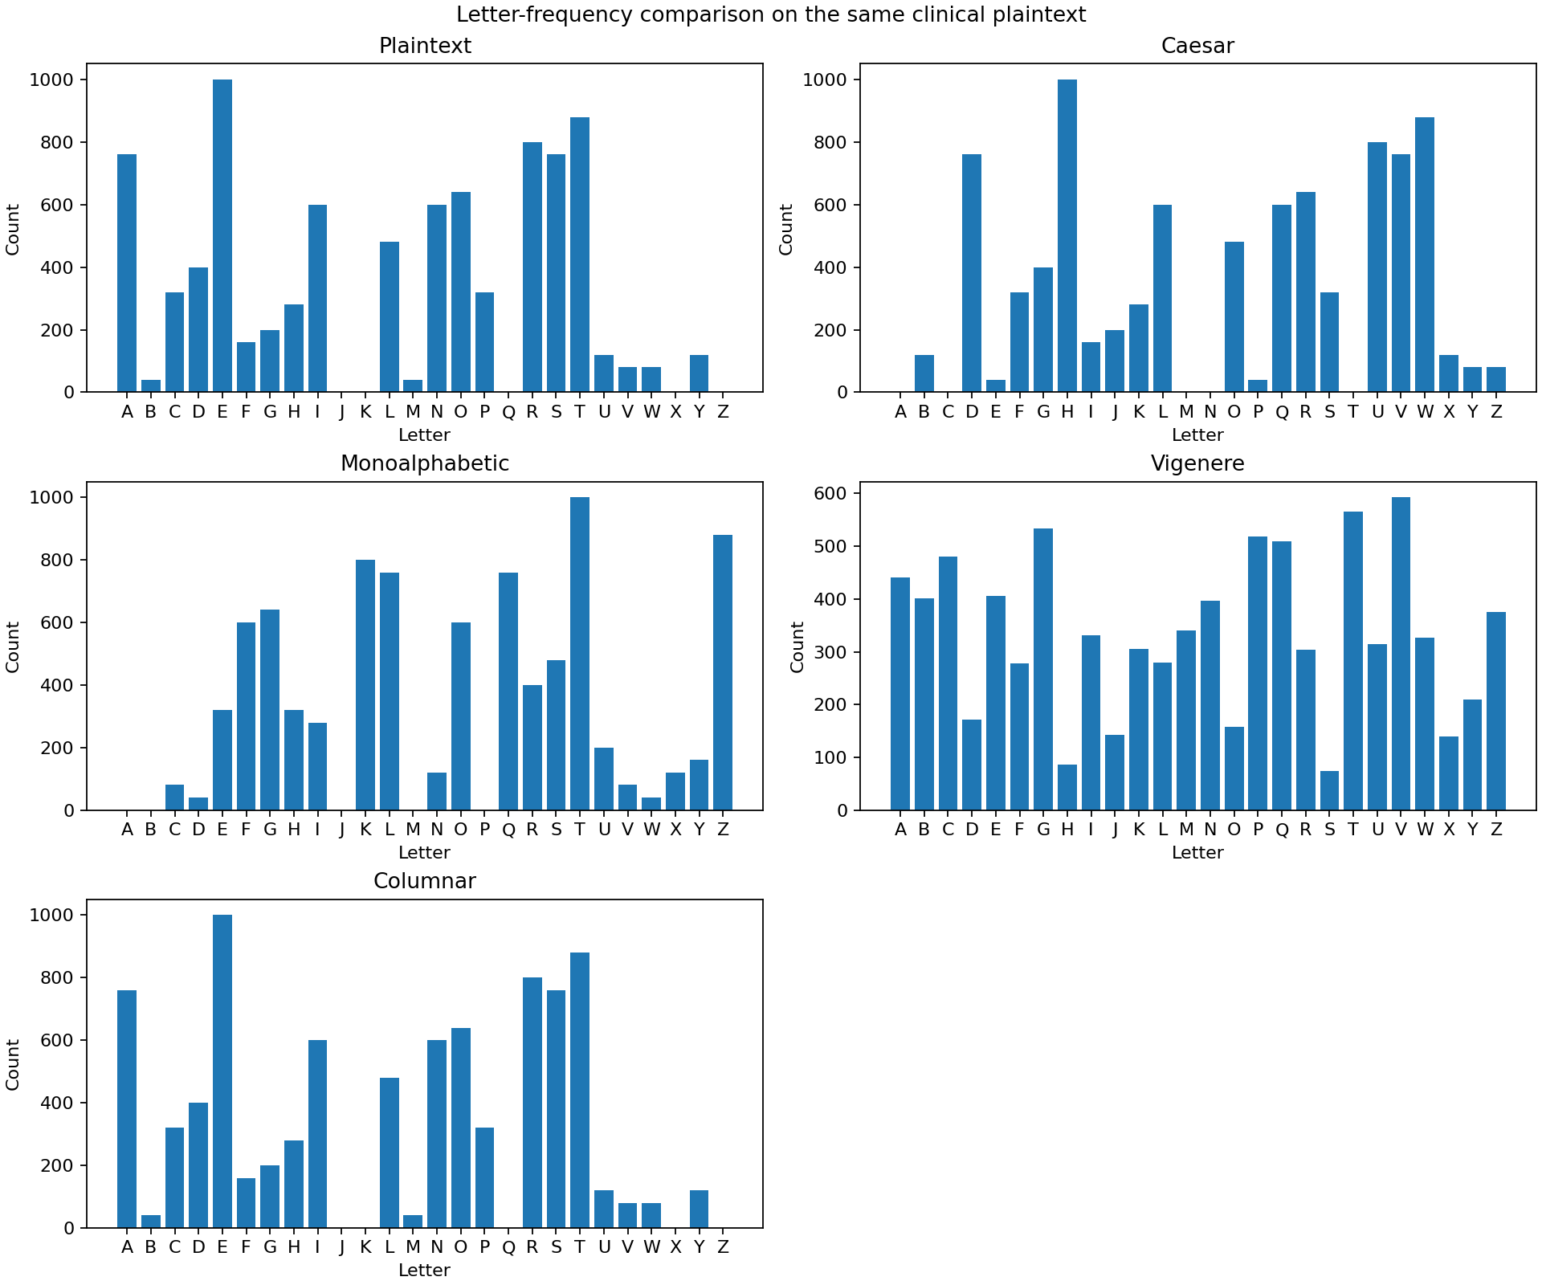
Figure 3. Letter-frequency histograms from the same repeated clinical plaintext and the indicated ciphertexts.
Interpretation: Caesar shifts the labels of letter counts but preserves the histogram shape. Monoalphabetic substitution also preserves the same count multiset under a different letter mapping. Columnar transposition preserves every count exactly because it only changes position. Vigenere combines different key shifts across positions, reducing the simple monogram pattern in this experiment.

10.2 Index of coincidence
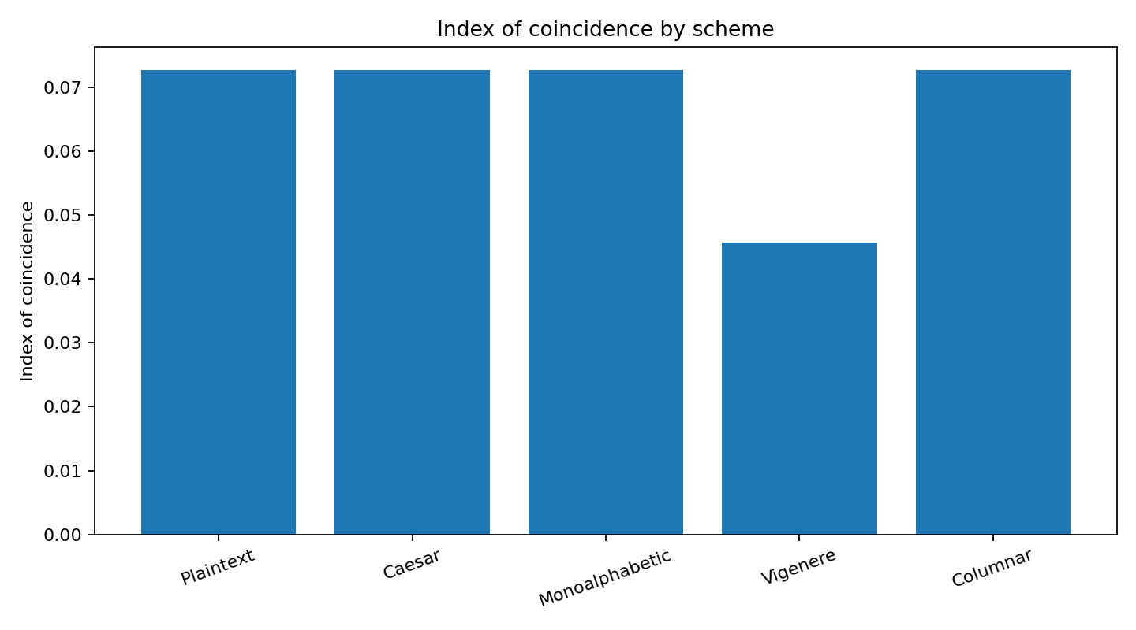
Text / scheme | Measured IC
Plaintext | 0.072670
Caesar | 0.072670
Monoalphabetic | 0.072670
Vigenere (CLINIC) | 0.045752
Columnar transposition | 0.072670

Interpretation: Caesar, monoalphabetic substitution and columnar transposition preserve the IC of the underlying text in this example. Vigenere lowers the IC by mixing several shifts. The synthetic plaintext repeats the same clinical phrase many times, so its IC is higher than a typical broad English corpus; the comparison is meaningful within this same-text experiment, but the absolute values should not be generalized to every clinical note.

10.3 Encryption and decryption time
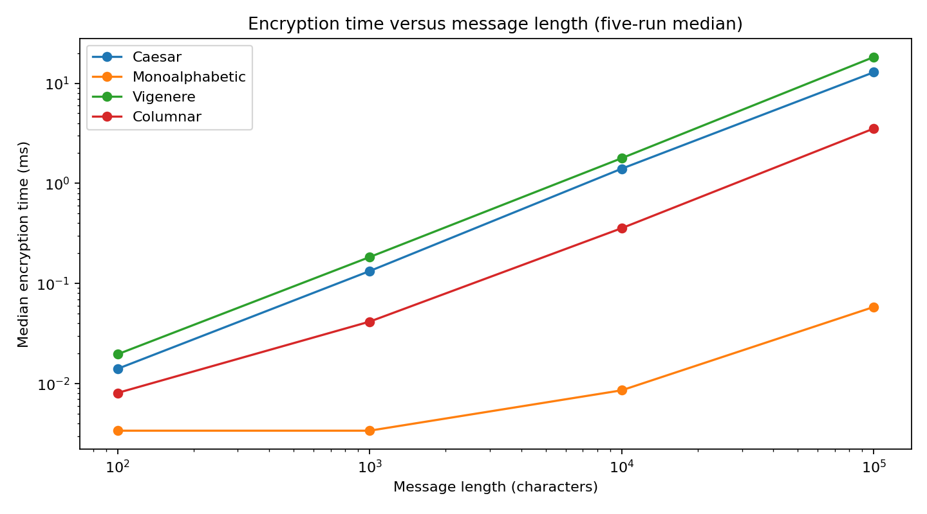
Characters | Scheme | Encrypt median (ms) | Decrypt median (ms)
100 | Caesar | 0.0141 | 0.0141
100 | Monoalphabetic | 0.0034 | 0.003
100 | Vigenere | 0.0197 | 0.0197
100 | Columnar | 0.0081 | 0.008
1000 | Caesar | 0.1333 | 0.1332
1000 | Monoalphabetic | 0.0034 | 0.0033
1000 | Vigenere | 0.1839 | 0.1875
1000 | Columnar | 0.0417 | 0.0572
10000 | Caesar | 1.4019 | 1.3769
10000 | Monoalphabetic | 0.0086 | 0.0087
10000 | Vigenere | 1.7849 | 1.8398
10000 | Columnar | 0.3572 | 0.563
100000 | Caesar | 12.8588 | 13.273
100000 | Monoalphabetic | 0.0584 | 0.0584
100000 | Vigenere | 18.2418 | 18.3201
100000 | Columnar | 3.5265 | 6.5632

Interpretation: execution time generally grows with message length. In this Python implementation, monoalphabetic substitution uses the optimized built-in str.translate operation and is much faster than the Python-level loops used by Caesar and Vigenere. This is an implementation-language effect, not evidence that monoalphabetic substitution is cryptographically stronger. Columnar transposition has a larger decryption cost because it reconstructs a rectangular matrix.
Environment: Python 3.13.5 on Linux x86_64 in the preparation runtime. Five-run medians are shown. Results will differ on a student laptop, browser environment or different Python version; the provided script should be run again on the target machine before reporting local timings.

10.4 Attack success against ciphertext length
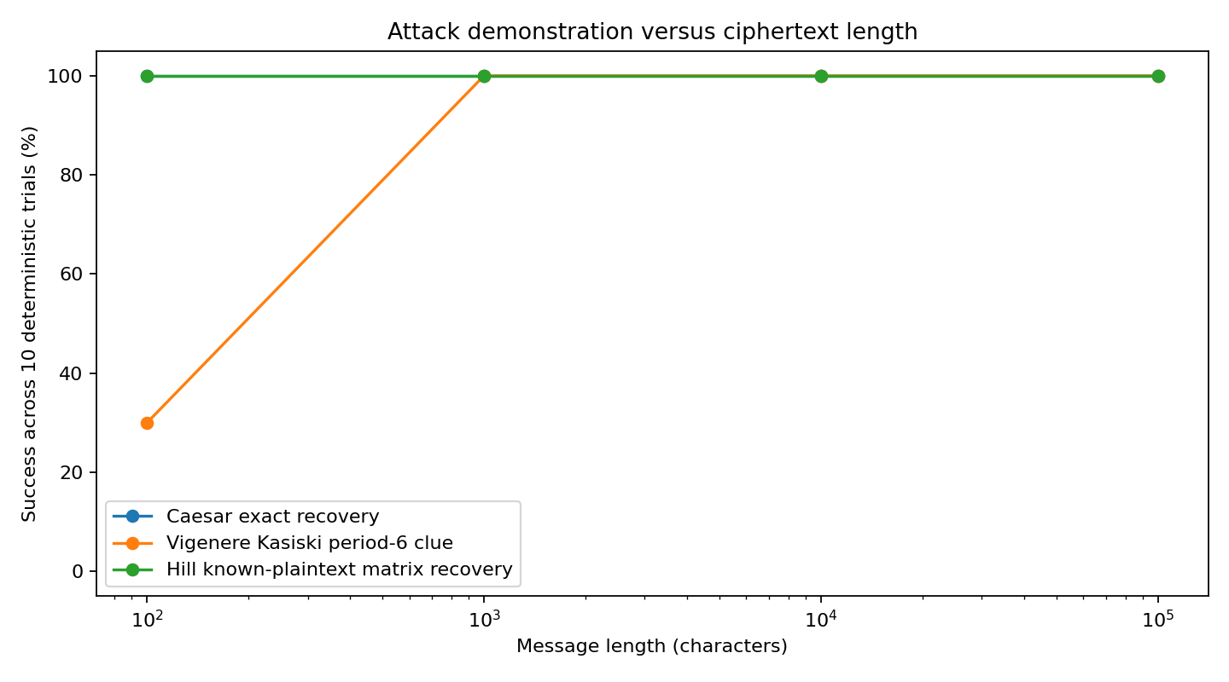
Length | Trials | Caesar exact recovery | Vigenere period-6 Kasiski clue | Hill key recovery
100 | 10 | 100.0% | 30.0% | 100.0%
1000 | 10 | 100.0% | 100.0% | 100.0%
10000 | 10 | 100.0% | 100.0% | 100.0%
100000 | 10 | 100.0% | 100.0% | 100.0%

Attack definition matters: Caesar success means exact key and plaintext recovery by unigram-frequency scoring; Vigenere success means the repeated-trigram distances contain the true key period 6 as a divisor (this detects a period clue, not the full keyword); Hill success means exact 3×3 matrix recovery from three independent known block pairs. Ten deterministic rotated-text trials were used for Caesar and Vigenere at each size. The Hill known-plaintext basis-block demonstration is algebraically exact, so it is shown as 100% when those three pairs are available. These are controlled demonstration rates, not real-world attacker probabilities.

10.5 Image entropy and spatial structure
Image case | Entropy (bits/pixel) | Horizontal adjacent-pixel correlation | Decryption
Synthetic cover | 5.584162 | 0.990059 | Original
Intensity shift mod 256 | 5.584162 | 0.990059 | Exact
Pixel permutation | 5.584162 | -0.001848 | Exact

Interpretation: intensity shifting adds k modulo 256 at each unchanged coordinate. It circularly shifts the histogram, preserves entropy and preserves the image’s spatial correlation; therefore the anatomical-like structure is still visible. Pixel permutation leaves the histogram and entropy exactly unchanged but destroys local spatial correlation in this test. It hides spatial arrangement better, yet leaks the global intensity distribution. Neither operation is a secure image cipher.
TASK 11 - Recommend and Defend the Final Design (4 Marks)

11.1 Recommended academic design
Within the assignment’s classical-only constraint, use a layered Vigenere substitution followed by columnar transposition, combined with Bell-LaPadula access labels and compartments. Use separate clinic-specific keys and a fresh session key for each exchange; never reuse a single network-wide key across all 25 clinics. This recommendation is relative to the weak classical options evaluated, not a claim of modern cryptographic security.
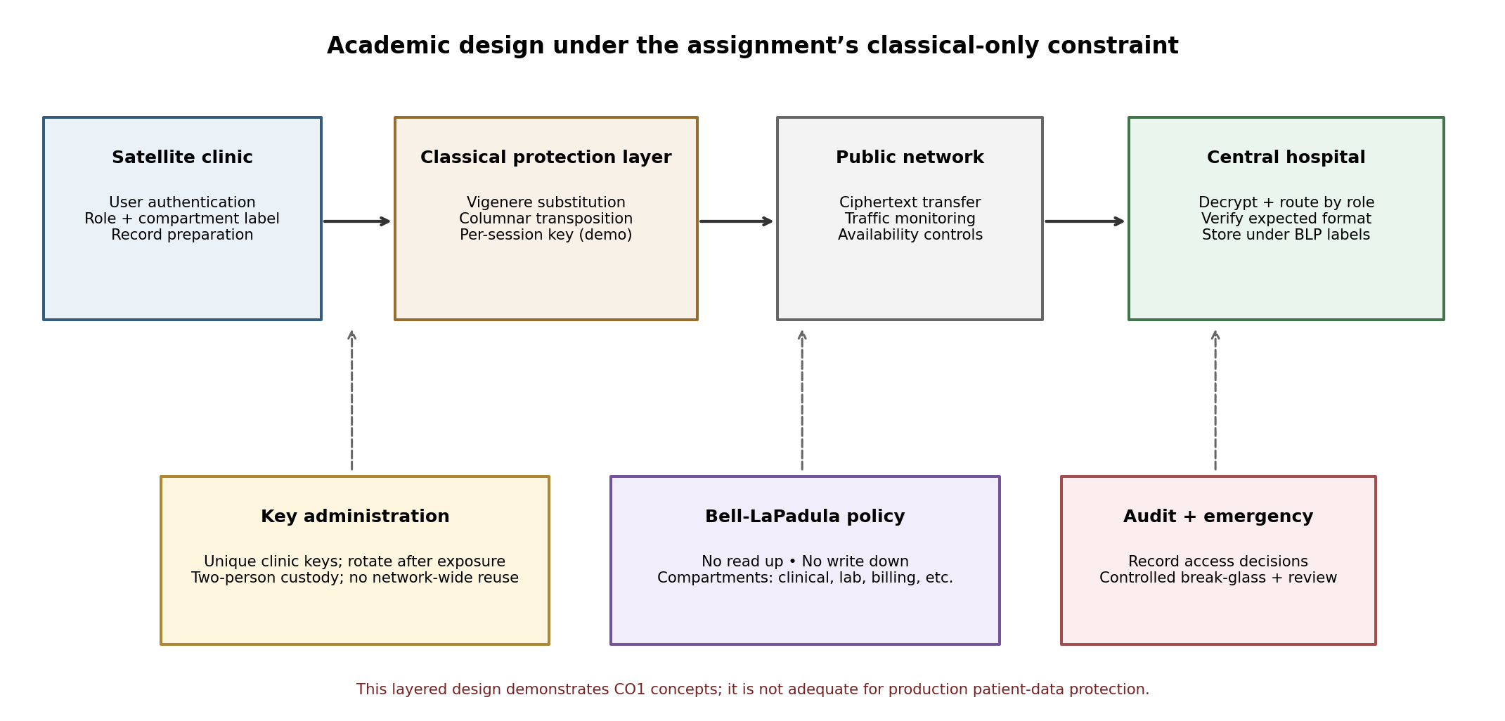
Figure 4. Academic architecture for the 25-clinic network under the classical-only assignment constraint.
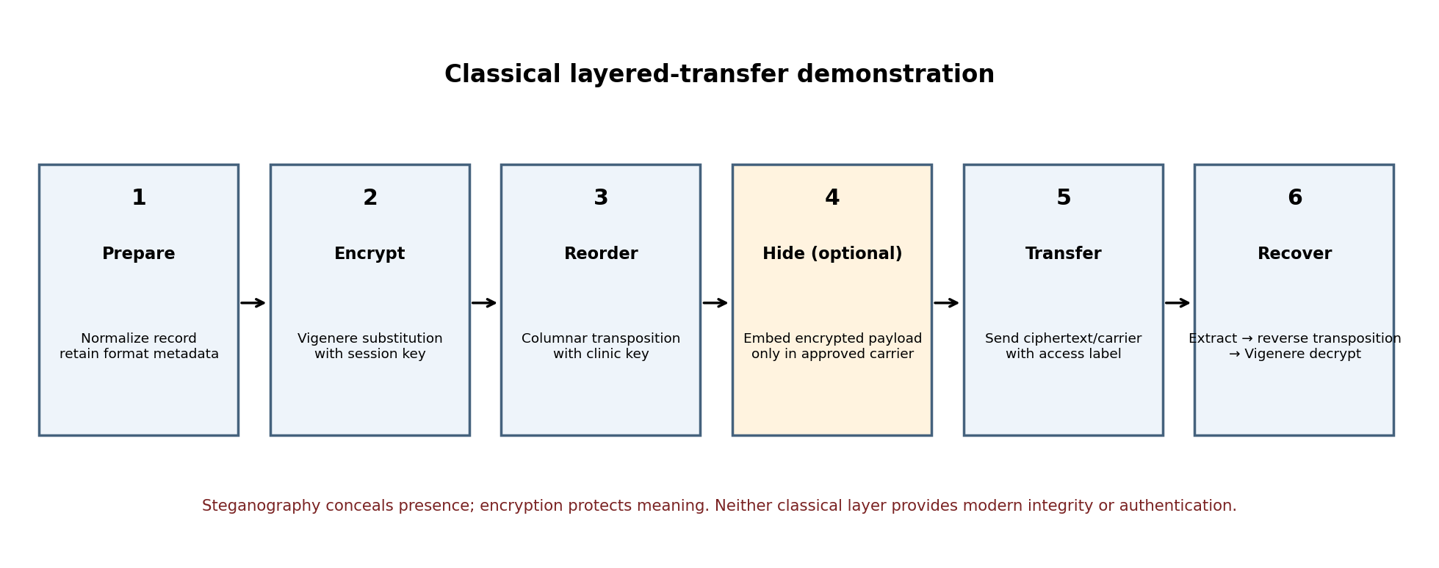
Figure 5. Classical layered exchange and optional encrypt-then-embed workflow.

11.2 Defence against alternatives
Alternative | Why it is weaker for this scenario
Caesar | Only 25 shifts; brute force is immediate.
Monoalphabetic substitution | Fixed letter mapping exposes frequency patterns despite 26! keys.
Columnar alone | Preserves exact monogram frequencies and has only n! arrangements for n columns.
Vigenere alone with repeated keyword | Better simple-frequency resistance, but repeated key and long ciphertext enable Kasiski/IC analysis.
Hill alone | Block mixing does not prevent a known-plaintext linear-algebra attack.
Vigenere + columnar | Adds two different transformations and frustrates casual single-method analysis; still not resistant to a well-resourced known-plaintext attacker.

11.3 Key distribution across 25 clinics
- Assign a distinct clinic key to each site; do not use one shared key across all clinics. Compromise at one site should not expose every other site.
- For each exchange, generate a separate session key and record the sender clinic, recipient, key identifier, validity window and retirement status. Reusing a short Vigenere keyword still leaks periodic structure; per-session uniqueness reduces the volume collected under one key but does not make the cipher modern-secure.
- Under the classroom’s classical-only constraint, distribute key material through a controlled out-of-band process, such as sealed, numbered envelopes with two-person custody and a key register. Rotate keys after staff departure or suspected exposure and securely destroy retired copies.
- Provide a simple automated workflow for rural staff. Staff should not manually perform long cipher calculations during patient care. The software must preserve formatting metadata and clearly warn when an expired or wrong key is selected.

11.4 Residual risks and real deployment judgement
Residual risks include frequency and known-plaintext attacks, insider access to keys, key copying, forged messages by any key-holder, undetected ciphertext manipulation, message replay, traffic analysis, denial of service, implementation errors and emergency override misuse. The classical design cannot guarantee strong integrity, modern sender authentication, non-repudiation, secure public-key key establishment, forward secrecy or robust availability. Therefore, classical ciphers are not acceptable for real patient-data protection. A production deployment would need modern authenticated encryption, digital signatures or an equivalent identity-bound integrity control, secure key management, replay protection, audit logging, resilient availability controls and clinical validation. These requirements are stated as real-world limitations and are not silently added to the classical-only design.

TASK 12 - Re-evaluate and Adapt the Design: Day-4 Challenge (8 Marks)
This section addresses all four 2-mark rubric components: A. Impact Analysis, B. Evaluation of Original Design, C. Adaptation/Redesign, and D. Evidence-Based Defence.

12.A Impact analysis (2 Marks)
The threat model changes from mainly an external attacker observing the public network to an insider at a satellite clinic who has already copied ciphertexts for months. The insider may know the message format, sender patterns, key handling process and predictable headers such as PATIENT ID, DIAGNOSIS and PRESCRIPTION. Hundreds of messages under the same key provide repeated observations and likely known-plaintext positions.
- Failed assumption: one long-term key can remain secret at all 25 sites. An insider at one site may copy it or collect messages encrypted with it.
- Failed assumption: ciphertexts are independent. Reusing one key creates statistical relationships across messages.
- Failed assumption: message prefixes are unknown. Predictable headers give known-plaintext cribs and alignment information.
- Failed assumption: hiding the message alone is enough. LSB steganography may be detected or destroyed by image conversion; it does not encrypt content.
A large corpus changes the risk ranking because frequency counts become more stable, repeated key periods become easier to identify, known formats provide cribs, and a compromised key may expose historical and future traffic until it is retired. Insider collection also bypasses some perimeter assumptions: the person is already inside an authorized clinic environment.

12.B Evaluate the original design (2 Marks)
The original classical options fail in different ways under the new attacker. Caesar is defeated by testing all 25 shifts. Monoalphabetic substitution exposes a stable frequency mapping. Vigenere with a repeated CLINIC keyword exhibits a six-character period; Kasiski analysis becomes more reliable as the available ciphertext grows. Hill encryption is linear and can be recovered from sufficient independent known-plaintext blocks. Columnar transposition preserves the exact letter histogram and does not stop the insider from collecting the ciphertext corpus.
The measured controlled demonstration supports these findings. Caesar frequency scoring recovered the exact shift in all 10 rotated-text trials at 100 characters and at every larger tested length. The Kasiski period-6 clue appeared in 3 of 10 trials at 100 characters and 10 of 10 at 1,000, 10,000 and 100,000 characters. The Hill matrix was recovered exactly from the three designed independent block pairs. These figures describe the reproducible synthetic tests only; they are not universal probabilities.
Bell-LaPadula still helps when a user tries to read above their clearance or write sensitive data down to a lower label. It is irrelevant to an insider who is legitimately authorized to read the ciphertext and already possesses the decryption key. BLP is a confidentiality label policy, not a cryptographic integrity mechanism, key-custody control or insider-monitoring system.

12.C Adaptation or redesign (2 Marks)
Change | What changes | Effect and limitation
Per-clinic keys | Each of the 25 clinics has a unique key identifier and key material. | Compromise at one clinic is less likely to expose all sites; key administration becomes more complex.
Per-session keys and rotation | Use a fresh session key for every exchange; retire keys after use or after a short validity window. | Reduces ciphertext volume under one key; does not make a repeated-key classical cipher unbreakable within that session.
Remove predictable headers / random padding | Move fixed labels out of the encrypted text where safe; pad messages to length buckets and avoid predictable plaintext prefixes. | Reduces easy cribs and length leakage but does not remove all language redundancy or guarantee security.
Layer Vigenere then columnar transposition | Apply polyalphabetic substitution and then a separate columnar rearrangement key. | Increases casual-analysis effort and adds independent key choices; frequency/period/known-plaintext attacks still apply.
Encrypt then embed | Encrypt the short report first, then embed its ciphertext in LSBs of a lossless carrier only if medically approved. | Discovery of the payload does not reveal the plaintext, but LSB data remains fragile and can alter pixels.
Strengthen BLP operation | Recheck user level and compartments for each action; audit exceptional access; require two-person declassification. | Reduces unauthorized disclosure paths; cannot stop a key-holder from copying data they are authorized to see.

12.D Evidence-based defence (2 Marks)
Key-space mathematics: Caesar has only 25 shifts; a six-character Vigenere key has 26^6 = 308,915,776 possible keys; an 8-column transposition has 8! = 40,320 permutations; the selected 2×2 Hill key is one of 157,248 invertible matrices mod 26. The 3×3 mod-36 Hill key space is large (19,016,370,487,296), but a sufficiently informative known-plaintext set still recovers the actual key. A large space cannot compensate for structural weakness or key reuse.
Experimental evidence: the same-text IC comparison shows Vigenere reducing the measured IC from 0.072670 to 0.045752, while Caesar, monoalphabetic substitution and transposition retain 0.072670. The controlled Kasiski test found the six-character period clue more consistently as ciphertext length increased. The image experiment measured 69.6117 dB PSNR for the tested LSB payload, exact recovery after lossless PNG, and failure after JPEG quality 95. These results support using fresh keys, layering, and lossless handling only as classroom mitigations—not as a secure production system.
Usability and key-management cost: per-clinic and per-session keys reduce the blast radius but create a distribution, backup, rotation and recovery workload across 25 rural sites. Two-person custody and a key register improve accountability but require training and offline coordination. A simple application should handle transformations automatically; staff should not remember or manually transpose clinical values.
Final judgement: redesign rather than retain the original shared-key approach. Use per-clinic isolation, fresh per-session keys, key retirement after exposure, randomized formatting/padding, a Vigenere-plus-columnar educational layer, strict BLP compartments, and optional encrypt-then-embed for an approved lossless carrier. This reduces shared-key exposure and casual cryptanalysis while preserving the assignment’s classical-only scope. It still cannot guarantee patient-data confidentiality against a capable attacker, detect all tampering, authenticate a doctor, provide non-repudiation, or protect a record once an authorized insider has copied it. A real healthcare deployment must replace these classical layers with modern authenticated cryptography and audited clinical workflows.
Overall conclusion
The assignment demonstrates that a secure patient-record exchange system needs multiple controls that address different security goals. Threat and risk ranking must consider patient safety. Bell-LaPadula gives a structured confidentiality policy, but emergencies and trusted declassification require carefully controlled governance. Classical ciphers provide useful CO1 learning examples and allow comparison through modular arithmetic, key-space derivations and cryptanalysis. The experiments confirm that larger key spaces do not automatically defeat frequency analysis, repeated-key attacks or known-plaintext attacks. Transposition and steganography add useful teaching concepts but do not create modern integrity or authentication.
For the Day-4 change, the shared-key design must be redesigned. Per-clinic and per-session key separation, key rotation, reduced predictable structure, layered transformations, controlled BLP exceptions and encrypt-then-embed reduce some risks. However, the final conclusion is explicit: classical ciphers alone are not suitable for protecting real patient records. Production healthcare systems require modern authenticated cryptography, secure key management, integrity verification, identity assurance, availability planning and clinical safety review.

Submission checklist against the rubric
- Task 1: at least six attacks, passive/active classes, threat/vulnerability/attack/risk definitions, L×I ranking and priority rationale.
- Task 2: all three system functions mapped to five security goals; classical-cipher gaps explained.
- Task 3: levels, subjects, objects, compartments, more than 12 access decisions, denied requests, emergency, declassification, tranquility and limitations.
- Task 4: at least three different classical schemes with key definitions, formulas and 20+ character worked examples.
- Task 5: key-space derivations, Hill invertibility and matrix inverse calculations.
- Task 6: brute force, frequency, Kasiski/IC and known-plaintext attacks with a resistance ranking.
- Task 7: 20-row transposition/checksum exercise, row-swap and compensating-attack analysis, product cipher reasoning.
- Task 8: image LSB and text acrostic, capacity, PSNR, chi-square indicator and JPEG test.
- Task 9: Python implementation, edge cases and reproducible commands.
- Task 10: histograms, IC, timing, attack demonstration and image entropy/spatial interpretation.
- Task 11: final defended design, residual risks, clinic key distribution and real deployment judgement.
- Task 12: impact analysis, original design evaluation, redesign and evidence-based defence.

References and source basis
Primary task wording, scenario, expected evidence and mark allocation: Assignment 1 - “Evaluate, Design and Defend a Secure Patient-Record Exchange Strategy for a Multi-Hospital Healthcare Network”, supplied 11-page assignment brief (CO1, total 50 marks).
Bell, D. E., & LaPadula, L. J. (1973). Secure computer systems: Mathematical foundations. MITRE Corporation, MTR-2547, Vol. I.
Shannon, C. E. (1949). Communication theory of secrecy systems. Bell System Technical Journal, 28(4), 656–715.
Note: The reference entries support the classical confidentiality-model and secrecy-system background. The detailed marking requirements and scenario-specific constraints are taken from the supplied assignment brief.

